- Complete registration form

- Code:

- Register.html
- <form action="#" id="registerForm" novalidate>

- <div class="form-field">
- <label for="name">Full Name</label>
- <input type="text"
- id="name"
- name="name"
- placeholder="Enter Full Name (Alphabet only)">
- <small class="error-msg" id="nameError"></small>
- </div>

- <div class="form-field">
- <label for="enrollment">Enrollment Number</label>
- <input type="text"
- id="enrollment"
- name="enrollment"
- placeholder="e.g. 25CS063 or D25CS063"
- minlength="7"
- maxlength="8">
- <small class="error-msg" id="enrollmentError"></small>
- </div>

- <div class="form-field">
- <label for="email">Email Address</label>
- <input type="email"
- id="email"
- name="email"
- placeholder="example@gmail.com">
- <small class="error-msg" id="emailError"></small>
- </div>

- <div class="form-field">
- <label for="mobile">Mobile Number</label>
- <input type="tel"
- id="mobile"
- name="mobile"
- placeholder="Enter 10 digit mobile number">
- <small class="error-msg" id="mobileError"></small>
- </div>

- <div class="form-field">
- <label for="course">Course</label>
- <select id="course" name="course">
- <option value="">Select Course</option>
- <option value="B.Tech CSE">B.Tech CSE</option>
- <option value="B.Tech IT">B.Tech IT</option>
- <option value="BCA">BCA</option>
- <option value="MCA">MCA</option>
- </select>
- <small class="error-msg" id="courseError"></small>
- </div>

- <div class="form-field">
- <label for="year">Academic Year</label>
- <select id="year" name="year">
- <option value="">Select Year</option>
- <option value="1st Year">1st Year</option>
- <option value="2nd Year">2nd Year</option>
- <option value="3rd Year">3rd Year</option>
- <option value="4th Year">4th Year</option>
- </select>
- <small class="error-msg" id="yearError"></small>
- </div>

- <div class="form-field">
- <label>Gender</label>

- <input type="radio" id="male" name="gender" value="Male">
- <label for="male">Male</label>

- <input type="radio" id="female" name="gender" value="Female">
- <label for="female">Female</label>

- <input type="radio" id="other" name="gender" value="Other">
- <label for="other">Other</label>

- <small class="error-msg" id="genderError"></small>
- </div>

- Screenshort:

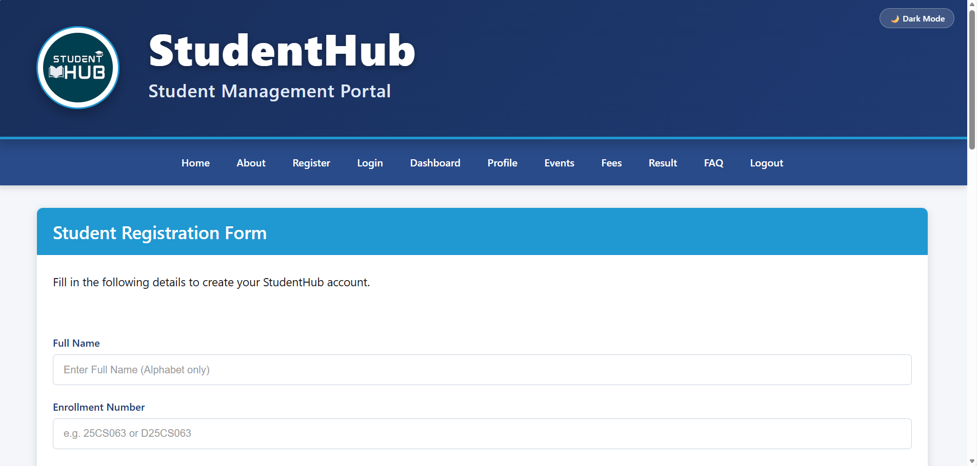

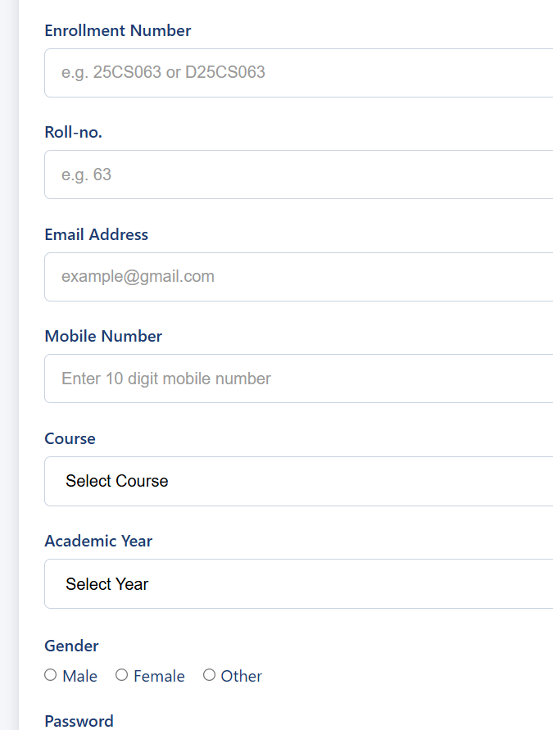

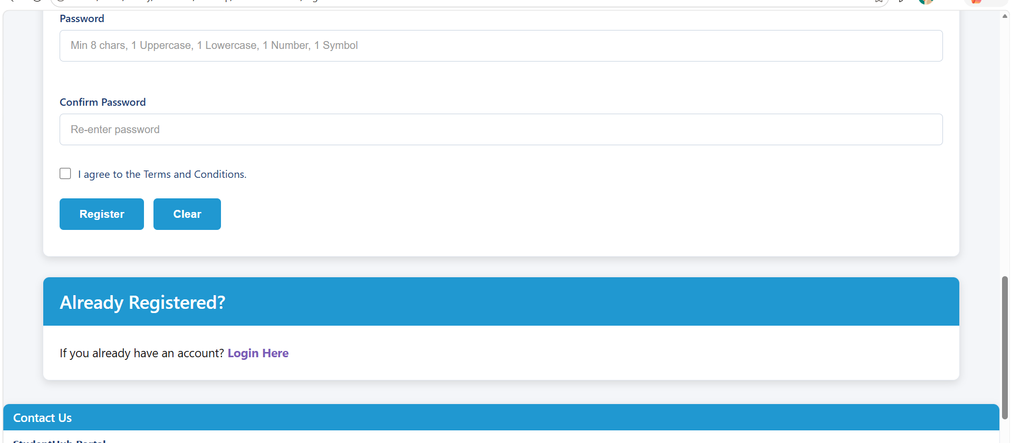

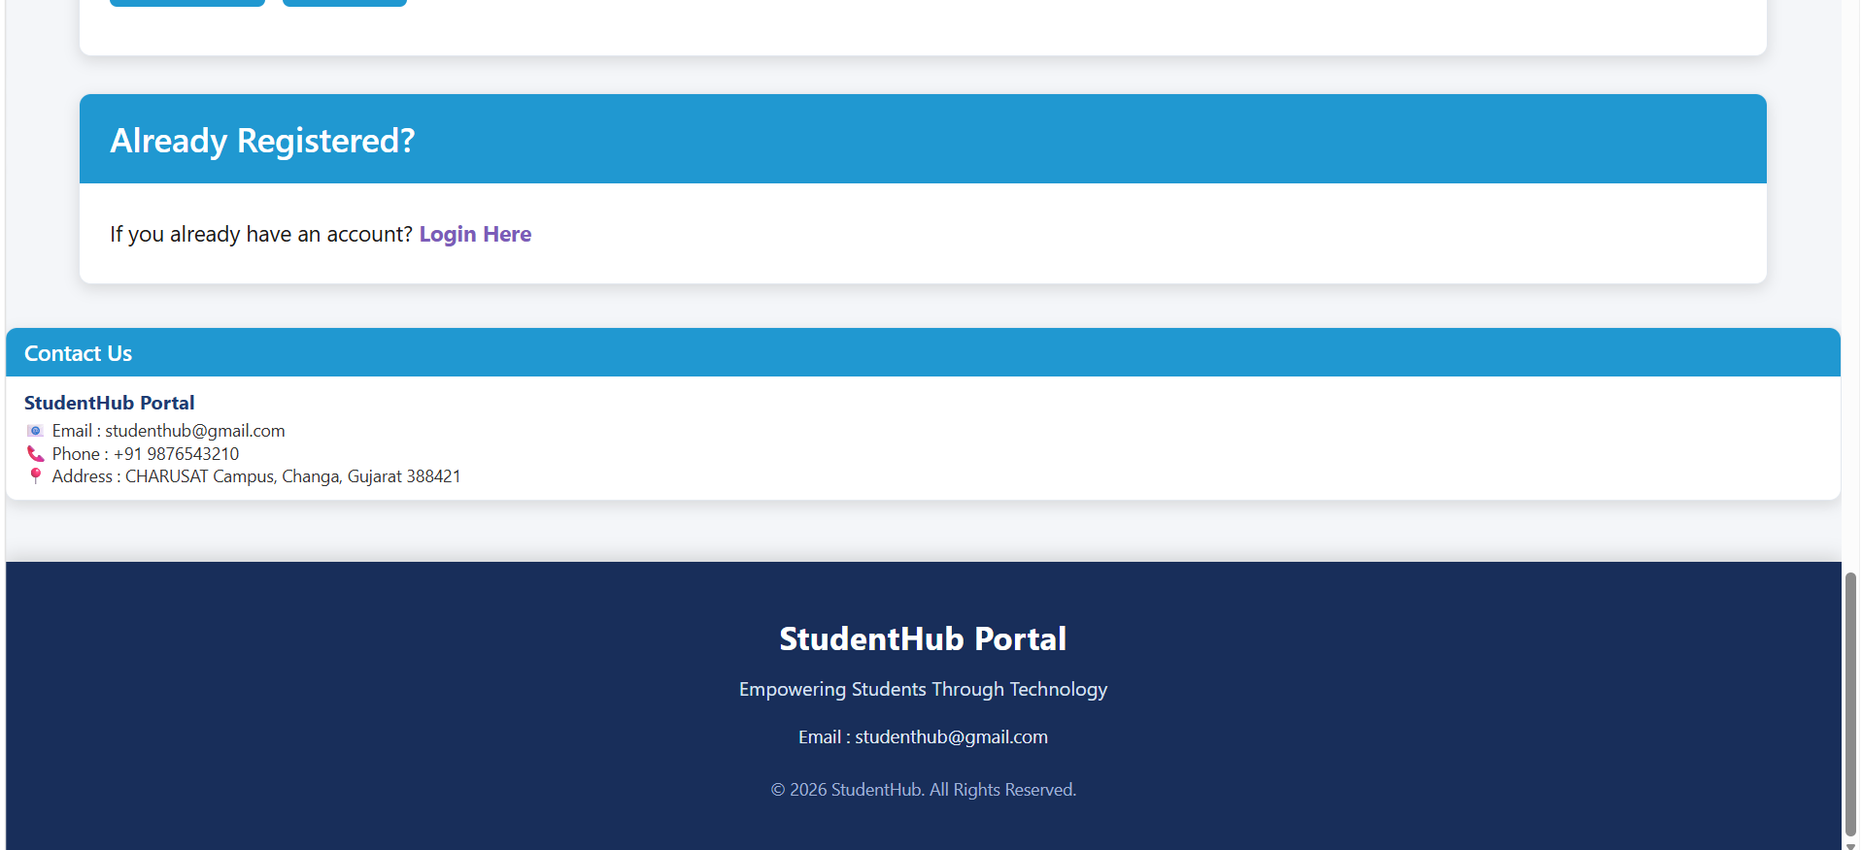

- Valid input + successful validation

Code:

Myscript.js

if (valid) {
successMsg.textContent =
"✓ Registration Completed Successfully!";
}

Screenshort:

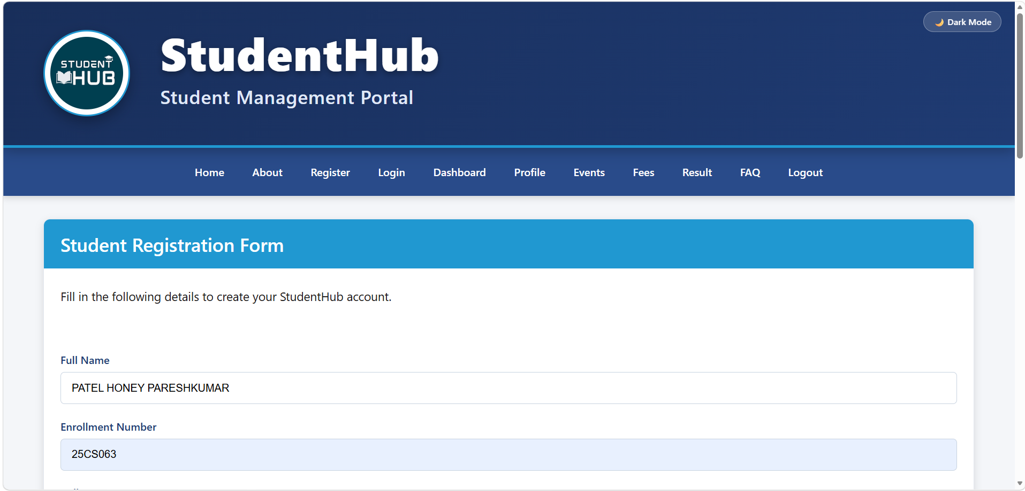

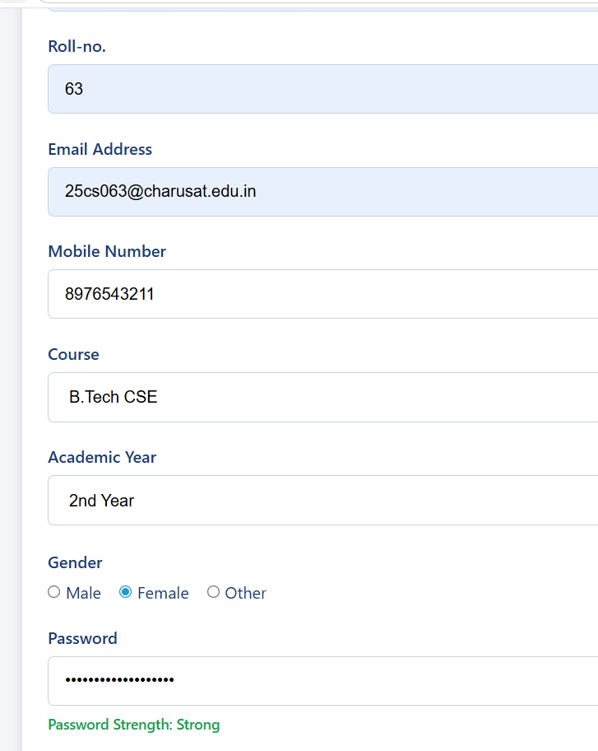

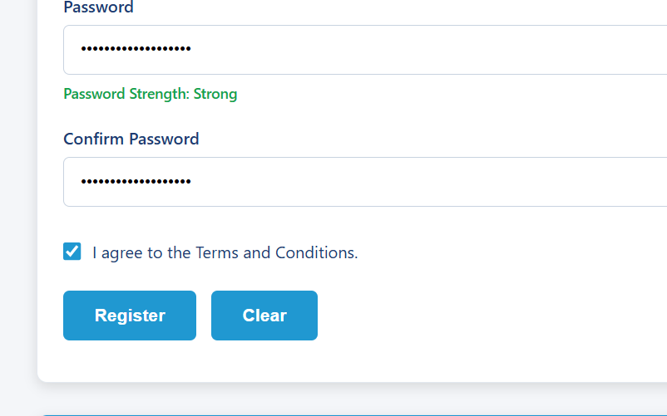

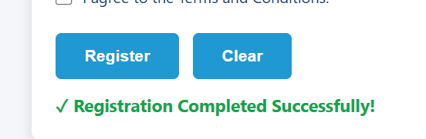

- Invalid name/email/mobile
- Code:

Myscript.js

if (!nameRegex.test(name.value)) {
nameError.textContent =
"Please enter a valid name.";
valid = false;
}

if (!emailRegex.test(email.value)) {
emailError.textContent =
"Email must contain lowercase letters only with proper format.";
valid = false;
}

if (!mobileRegex.test(mobile.value)) {
mobileError.textContent =
"Please enter a valid 10-digit Indian Mobile Number.";
valid = false;
}

const nameRegex = /^[A-Za-z ]+$/;

const emailRegex =
/^[a-z0-9]+@[a-z0-9.-]+\.[a-z]{2,}$/;

const mobileRegex =
/^[6-9]\d{9}$/;

- Screenshort:

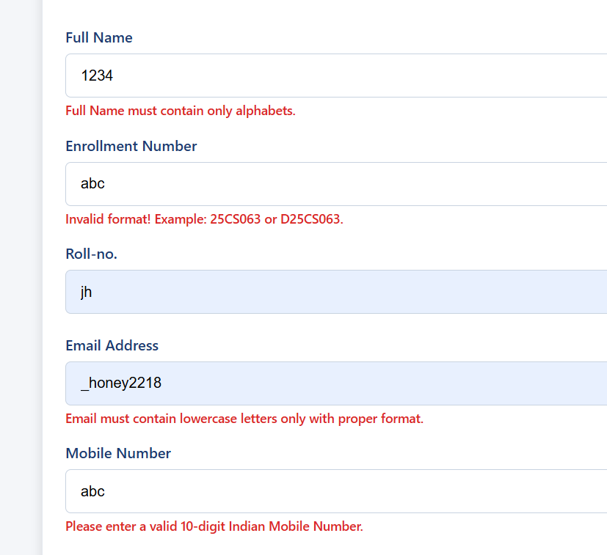

- Password & confirm-password validation

- Code:
Register.html

<div class="form-field">
<label for="password">Password</label>

<input type="password"
id="password"
name="password"
placeholder="Min 8 chars, 1 Uppercase, 1 Lowercase, 1 Number, 1 Symbol">

<div id="passwordStrength" class="password-strength"></div>

<small class="error-msg" id="passwordError"></small>
</div>

<div class="form-field">
<label for="confirm">Confirm Password</label>

<input type="password"
id="confirm"
name="confirm"
placeholder="Re-enter password">

<small class="error-msg" id="confirmError"></small>
</div>

<div class="form-field">
<div class="terms-container">
<input type="checkbox" id="terms">
<label for="terms">
I agree to the Terms and Conditions.
</label>
</div>

<small class="error-msg" id="termsError"></small>
</div>

<div class="buttons">
<input type="submit" value="Register">
<input type="reset" value="Clear" id="resetBtn">
</div>

<div id="successMsg" class="success-display"></div>

Myscript.js

const passwordRegex =
/^(?=.*[A-Z])(?=.*[a-z])(?=.*\d)(?=.*[^A-Za-z0-9]).{8,}$/;

if (!passwordRegex.test(password.value)) {
passwordError.textContent =
"Password must be min 8 chars with 1 uppercase, 1 lowercase, 1 digit, and 1 special symbol.";
valid = false;
}

if (confirm.value !== password.value) {
confirmError.textContent =
"Password and Confirm Password do not match.";
valid = false;
}

- Screenshort:

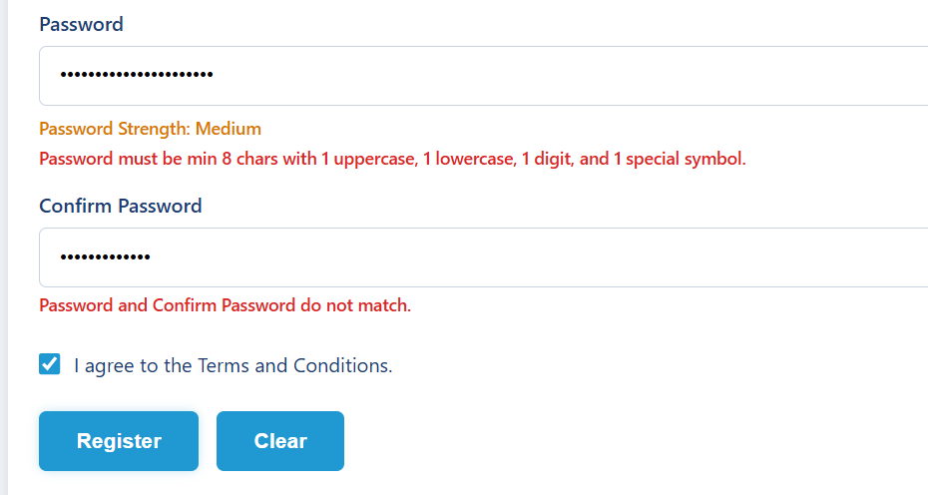

- Password strength

- Code:

Myscript.js

password.addEventListener("input", function () {

const value = password.value;

let strength = 0;

if (value.length >= 8)
strength++;

if (/[A-Z]/.test(value))
strength++;

if (/[a-z]/.test(value))
strength++;

if (/[0-9]/.test(value))
strength++;

if (/[^A-Za-z0-9]/.test(value))
strength++;

if (value.length === 0) {
passwordStrength.textContent = "";
}
else if (strength <= 2) {
passwordStrength.textContent =
"Password Strength: Weak";
}
else if (strength <= 4) {
passwordStrength.textContent =
"Password Strength: Medium";
}
else {
passwordStrength.textContent =
"Password Strength: Strong";
}
});

- Screenshort:

If password is xyz

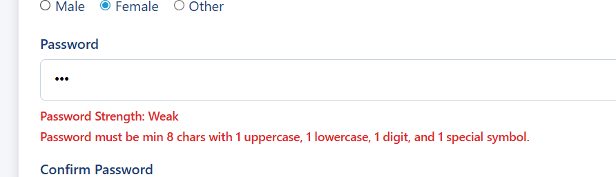

If password is xyz@123

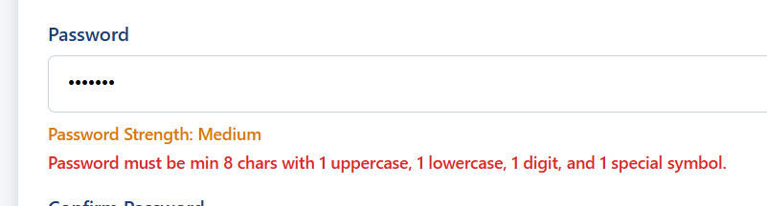

If password is xyz@12345

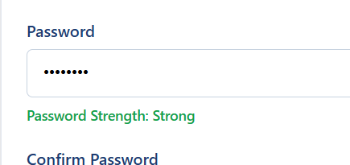

- Terms not accepted

Code:

Myscript.js

if (!terms.checked) {
termsError.textContent =
"You must agree to the Terms and Conditions.";
valid = false;
}

if (valid) {
successMsg.textContent =
"✓ Registration Completed Successfully!";
}

Screenshort:

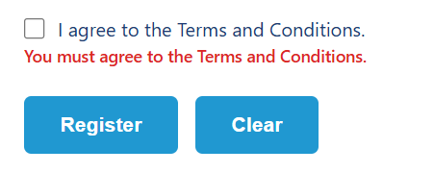

ALL CODES

Register.html

<!DOCTYPE html>
<html lang="en">

<head>
<meta charset="UTF-8">
<meta name="viewport" content="width=device-width, initial-scale=1.0">
<title>StudentHub | Register</title>
<link rel="stylesheet" href="style4.css">
</head>

<body>

<!-- ===============================
HEADER
================================ -->
<header>
<div class="container">
<div class="top">
<div class="logo">
<img src="image.jpg" alt="StudentHub Logo">
<div>
<h1>StudentHub</h1>
<h3>Student Management Portal</h3>
</div>
</div>
<button class="theme-btn" id="themeBtn">🌙 Dark Mode</button>
</div>
</div>
</header>

<!-- Navigation Section -->
<div class="nav-section">
<div class="container">
<nav id="navbar">
<a href="home.html">Home</a>
<a href="about.html">About</a>
<a href="register.html">Register</a>
<a href="login.html">Login</a>
<a href="dashboard.html">Dashboard</a>
<a href="profile.html">Profile</a>
<a href="event.html">Events</a>
<a href="fees.html">Fees</a>
<a href="result.html">Result</a>
<a href="FAQ.html">FAQ</a>
<a href="logout.html">Logout</a>
</nav>
</div>
</div>

<main>
<div class="card">
<h2>Student Registration Form</h2>
<p>Fill in the following details to create your StudentHub account.</p>

<form action="#" id="registerForm" novalidate>

<!-- Full Name -->
<div class="form-field">
<label for="name">Full Name</label>
<input type="text"
id="name"
name="name"
placeholder="Enter Full Name (Alphabet only)">
<small class="error-msg" id="nameError"></small>
</div>

<!-- Enrollment Number -->
<div class="form-field">
<label for="enrollment">Enrollment Number</label>
<input type="text" id="enrollment" name="enrollment" placeholder="e.g. 25CS063 or D25CS063" minlength="7" maxlength="8">
<small class="error-msg" id="enrollmentError"></small>
</div>

<!-- Roll Number -->
<div class="form-field">
<label for="Roll-no.">Roll-no.</label>
<input type="text" id="Roll-no." name="Roll-no." placeholder="e.g. 63">
<small class="error-msg" id="Roll-no."></small>
</div>

<!-- Email Address -->
<div class="form-field">
<label for="email">Email Address</label>
<input type="email" id="email" name="email" placeholder="example@gmail.com">
<small class="error-msg" id="emailError"></small>
</div>

<!-- Mobile Number -->
<div class="form-field">
<label for="mobile">Mobile Number</label>
<input type="tel" id="mobile" name="mobile" placeholder="Enter 10 digit mobile number">
<small class="error-msg" id="mobileError"></small>
</div>

<!-- Course -->
<div class="form-field">
<label for="course">Course</label>
<select id="course" name="course">
<option value="">Select Course</option>
<option value="B.Tech CSE">B.Tech CSE</option>
<option value="B.Tech IT">B.Tech IT</option>
<option value="BCA">BCA</option>
<option value="MCA">MCA</option>
</select>
<small class="error-msg" id="courseError"></small>
</div>

<!-- Academic Year -->
<div class="form-field">
<label for="year">Academic Year</label>
<select id="year" name="year">
<option value="">Select Year</option>
<option value="1st Year">1st Year</option>
<option value="2nd Year">2nd Year</option>
<option value="3rd Year">3rd Year</option>
<option value="4th Year">4th Year</option>
</select>
<small class="error-msg" id="yearError"></small>
</div>

<!-- Gender -->
<div class="form-field">
<label style="margin-top:20px;">Gender</label>
<div class="gender">
<input type="radio" id="male" name="gender" value="Male">
<label for="male" style="display:inline;font-weight:normal;">Male</label>
&nbsp;&nbsp;
<input type="radio" id="female" name="gender" value="Female">
<label for="female" style="display:inline;font-weight:normal;">Female</label>
&nbsp;&nbsp;
<input type="radio" id="other" name="gender" value="Other">
<label for="other" style="display:inline;font-weight:normal;">Other</label>
</div>
<small class="error-msg" id="genderError"></small>
</div>

<!-- Password -->

<!-- Password -->

<div class="form-field">
<label for="password">Password</label>

<input type="password"
id="password"
name="password"
placeholder="Min 8 chars, 1 Uppercase, 1 Lowercase, 1 Number, 1 Symbol">

<div id="passwordStrength" class="password-strength"></div>

<small class="error-msg" id="passwordError"></small>
</div>

<!-- Confirm Password -->
<div class="form-field">
<label for="confirm">Confirm Password</label>

<input type="password"
id="confirm"
name="confirm"
placeholder="Re-enter password">

<small class="error-msg" id="confirmError"></small>
</div>

<!-- Terms and Conditions Proper Alignment -->
<div class="form-field" style="margin-top:20px;">
<div class="terms-container">
<input type="checkbox" id="terms">
<label for="terms">I agree to the Terms and Conditions.</label>
</div>
<small class="error-msg" id="termsError"></small>
</div>

<div class="buttons">
<input type="submit" value="Register">
<input type="reset" value="Clear" id="resetBtn">
</div>

<!-- Success Message Display Under Buttons -->
<div id="successMsg" class="success-display"></div>

</form>
</div>

<div class="card">
<h2>Already Registered?</h2>
<p>
If you already have an account?
<a href="login.html" style="color:#7B5CB8; font-weight:bold; text-decoration:none;">
Login Here
</a>
</p>
</div>
</main>

<div class="card contact-card">
<h2>Contact Us</h2>
<div class="contact-info">
<h3>StudentHub Portal</h3>
<p>📧 Email : studenthub@gmail.com</p>
<p>📞 Phone : +91 9876543210</p>
<p>📍 Address : CHARUSAT Campus, Changa, Gujarat 388421</p>
</div>
</div>

<footer>
<div class="footer-content">
<h2>StudentHub Portal</h2>
<p>Empowering Students Through Technology</p>
<p class="email">Email : studenthub@gmail.com</p>
<p class="copyright">&copy; 2026 StudentHub. All Rights Reserved.</p>
</div>
</footer>

<script src="myscript.js"></script>
</body>

</html>

Myscript.js
/* ======================================
NOTIFICATION BANNER CLOSE
====================================== */

const banner = document.getElementById("banner");
const closeBanner = document.getElementById("closeBanner");

if (closeBanner && banner) {
closeBanner.addEventListener("click", function () {
banner.style.display = "none";
});
}

/* ======================================
IMAGE / CONTENT SLIDER
====================================== */

const slider = document.getElementById("slider");

const slides = [
"📖 Welcome to StudentHub FAQ Center",
"🎓 Student Registration Made Easy",
"📢 Check Latest Events & Announcements",
"💳 View Fees & Payment Details",
"🏆 Access Your Semester Results"
];

let current = 0;

if (slider) {
setInterval(function () {
current++;

if (current >= slides.length) {
current = 0;
}

slider.innerHTML = slides[current];

}, 3000);
}

/* ======================================
FAQ COLLAPSIBLE
====================================== */

const faqButtons = document.querySelectorAll(".faq-btn");

faqButtons.forEach(function (button) {

button.addEventListener("click", function () {

const answer = this.nextElementSibling;
const icon = this.querySelector("span");

document.querySelectorAll(".faq-answer").forEach(function (item) {

if (item !== answer) {
item.style.display = "none";
}

});

document.querySelectorAll(".faq-btn span").forEach(function (item) {

if (item !== icon && item) {
item.innerHTML = "+";
}

});

if (answer && answer.style.display === "block") {

answer.style.display = "none";

if (icon) {
icon.innerHTML = "+";
}

} else if (answer) {

answer.style.display = "block";

if (icon) {
icon.innerHTML = "−";
}

}

});

});

/* ======================================
MODAL POPUP
====================================== */

const modal = document.getElementById("supportModal");
const openModal = document.getElementById("openModal");
const closeModal = document.getElementById("closeModal");

if (openModal && modal) {

openModal.addEventListener("click", function () {
modal.style.display = "block";
});

}

if (closeModal && modal) {

closeModal.addEventListener("click", function () {
modal.style.display = "none";
});

}

window.addEventListener("click", function (event) {

if (event.target === modal) {
modal.style.display = "none";
}

});

/* ======================================
DARK / LIGHT THEME
====================================== */

const themeBtn = document.getElementById("themeBtn");

if (localStorage.getItem("theme") === "dark") {

document.body.classList.add("dark");

if (themeBtn) {
themeBtn.innerHTML = "☀ Light Mode";
}

}

if (themeBtn) {

themeBtn.addEventListener("click", function () {

document.body.classList.toggle("dark");

if (document.body.classList.contains("dark")) {

themeBtn.innerHTML = "☀ Light Mode";

localStorage.setItem("theme", "dark");

} else {

themeBtn.innerHTML = "🌙 Dark Mode";

localStorage.setItem("theme", "light");

}

});

}

/* ======================================
HAMBURGER MENU
====================================== */

const menuBtn = document.getElementById("menuBtn");
const navbar = document.getElementById("navbar");

if (menuBtn && navbar) {

menuBtn.addEventListener("click", function () {

if (navbar.style.display === "flex") {

navbar.style.display = "none";

} else {

navbar.style.display = "flex";
navbar.style.flexDirection = "column";
navbar.style.alignItems = "center";

}

});

}

/* ======================================
REGISTER FORM VALIDATION
====================================== */

const registerForm = document.getElementById("registerForm");

if (registerForm) {

const resetBtn = document.getElementById("resetBtn");

/* ---------- RESET ---------- */

if (resetBtn) {

resetBtn.addEventListener("click", function () {

document.querySelectorAll(".error-msg").forEach(function (el) {
el.innerText = "";
});

const successMsg = document.getElementById("successMsg");

if (successMsg) {
successMsg.innerText = "";
}

const passwordStrength =
document.getElementById("passwordStrength");

if (passwordStrength) {
passwordStrength.innerText = "";
passwordStrength.className = "password-strength";
}

});

}

/* ---------- PASSWORD STRENGTH ---------- */

const passwordInput = document.getElementById("password");
const passwordStrength =
document.getElementById("passwordStrength");

if (passwordInput && passwordStrength) {

passwordInput.addEventListener("input", function () {

const password = passwordInput.value;

if (password === "") {

passwordStrength.innerText = "";
passwordStrength.className = "password-strength";

return;
}

let score = 0;

if (password.length >= 8) {
score++;
}

if (/[a-z]/.test(password)) {
score++;
}

if (/[A-Z]/.test(password)) {
score++;
}

if (/[0-9]/.test(password)) {
score++;
}

if (/[@$!%*?&]/.test(password)) {
score++;
}

if (score <= 2) {

passwordStrength.innerText =
"Password Strength: Weak";

passwordStrength.className =
"password-strength weak";

}

else if (score <= 4) {

passwordStrength.innerText =
"Password Strength: Medium";

passwordStrength.className =
"password-strength medium";

}

else {

passwordStrength.innerText =
"Password Strength: Strong";

passwordStrength.className =
"password-strength strong";

}

});

}

/* ---------- SUBMIT ---------- */

registerForm.addEventListener("submit", function (event) {

event.preventDefault();

let isValid = true;

/* Clear old errors */

document.querySelectorAll(".error-msg").forEach(function (el) {
el.innerText = "";
});

const successMsg = document.getElementById("successMsg");

if (successMsg) {
successMsg.innerText = "";
}

/* ---------- ELEMENTS ---------- */

const nameInput = document.getElementById("name");
const enrollmentInput =
document.getElementById("enrollment");
const rollInput =
document.getElementById("Roll-no.");
const emailInput =
document.getElementById("email");
const mobileInput =
document.getElementById("mobile");
const courseInput =
document.getElementById("course");
const yearInput =
document.getElementById("year");
const genderInputs =
document.getElementsByName("gender");
const passwordInput =
document.getElementById("password");
const confirmInput =
document.getElementById("confirm");
const termsInput =
document.getElementById("terms");

/* ---------- VALUES ---------- */

const nameVal =
nameInput ? nameInput.value.trim() : "";

const enrollmentVal =
enrollmentInput ? enrollmentInput.value.trim() : "";

const rollVal =
rollInput ? rollInput.value.trim() : "";

const emailVal =
emailInput ? emailInput.value.trim() : "";

const mobileVal =
mobileInput ? mobileInput.value.trim() : "";

const courseVal =
courseInput ? courseInput.value : "";

const yearVal =
yearInput ? yearInput.value : "";

const passwordVal =
passwordInput ? passwordInput.value : "";

const confirmVal =
confirmInput ? confirmInput.value : "";

/* ======================================
1. FULL NAME
====================================== */

const nameRegex = /^[A-Za-z\s]+$/;

if (nameInput) {

if (nameVal === "") {

document.getElementById("nameError").innerText =
"Please enter your Full Name.";

isValid = false;

}

else if (!nameRegex.test(nameVal)) {

document.getElementById("nameError").innerText =
"Full Name must contain only alphabets.";

isValid = false;

}

}

/* ======================================
2. ENROLLMENT NUMBER
====================================== */

const enrollmentError =
document.getElementById("enrollmentError");

const enrollmentPattern =
/^[Dd]?[0-9]{2}[a-zA-Z]{2}[0-9]{3}$/;

if (enrollmentInput) {

if (enrollmentVal === "") {

enrollmentError.innerText =
"Please enter Enrollment Number.";

isValid = false;

}

else if (!enrollmentPattern.test(enrollmentVal)) {

enrollmentError.innerText =
"Invalid format! Example: 25CS063 or D25CS063.";

isValid = false;

}

}

/* ======================================
3. ROLL NUMBER
====================================== */

if (rollInput) {

const rollError =
document.getElementById("Roll-no.");

const rollPattern = /^[0-9]{1,3}$/;

if (rollVal === "") {

rollError.innerText =
"Please enter Roll Number.";

isValid = false;

}

else if (!rollPattern.test(rollVal)) {

rollError.innerText =
"Roll Number must contain 1 to 3 digits.";

isValid = false;

}

}

/* ======================================
4. EMAIL
====================================== */

const emailRegex =
/^[a-z0-9._%+-]+@[a-z0-9.-]+\.[a-z]{2,}$/;

if (emailInput) {

if (emailVal === "") {

document.getElementById("emailError").innerText =
"Please enter your Email Address.";

isValid = false;

}

else if (!emailRegex.test(emailVal)) {

document.getElementById("emailError").innerText =
"Email must contain lowercase letters only with proper format.";

isValid = false;

}

}

/* ======================================
5. MOBILE
====================================== */

const mobileRegex = /^[6-9][0-9]{9}$/;

if (mobileInput) {

if (mobileVal === "") {

document.getElementById("mobileError").innerText =
"Please enter your Mobile Number.";

isValid = false;

}

else if (!mobileRegex.test(mobileVal)) {

document.getElementById("mobileError").innerText =
"Please enter a valid 10-digit Indian Mobile Number.";

isValid = false;

}

}

/* ======================================
6. COURSE
====================================== */

if (courseInput) {

if (courseVal === "") {

document.getElementById("courseError").innerText =
"Please select a Course.";

isValid = false;

}

}

/* ======================================
7. ACADEMIC YEAR
====================================== */

if (yearInput) {

if (yearVal === "") {

document.getElementById("yearError").innerText =
"Please select your Academic Year.";

isValid = false;

}

}

/* ======================================
8. GENDER
====================================== */

if (genderInputs.length > 0) {

let genderSelected = false;

for (let g of genderInputs) {

if (g.checked) {

genderSelected = true;
break;

}

}

if (!genderSelected) {

document.getElementById("genderError").innerText =
"Please select your Gender.";

isValid = false;

}

}

/* ======================================
9. PASSWORD
====================================== */

const passwordRegex =
/^(?=.*[a-z])(?=.*[A-Z])(?=.*\d)(?=.*[@$!%*?&])[A-Za-z\d@$!%*?&]{8,}$/;

if (passwordInput) {

if (passwordVal === "") {

document.getElementById("passwordError").innerText =
"Please enter a Password.";

isValid = false;

}

else if (!passwordRegex.test(passwordVal)) {

document.getElementById("passwordError").innerText =
"Password must be min 8 chars with 1 uppercase, 1 lowercase, 1 digit, and 1 special symbol.";

isValid = false;

}

}

/* ======================================
10. CONFIRM PASSWORD
====================================== */

if (confirmInput) {

if (confirmVal === "") {

document.getElementById("confirmError").innerText =
"Password and Confirm Password do not match.";

isValid = false;

}

else if (passwordVal !== confirmVal) {

document.getElementById("confirmError").innerText =
"Password and Confirm Password do not match.";

isValid = false;

}

}

/* ======================================
11. TERMS
====================================== */

if (termsInput) {

if (!termsInput.checked) {

document.getElementById("termsError").innerText =
"You must agree to the Terms and Conditions.";

isValid = false;

}

}

/* ======================================
SUCCESS
====================================== */

if (isValid) {

if (successMsg) {

successMsg.innerText =
"✓ Registration Completed Successfully!";

}

registerForm.reset();

if (passwordStrength) {

passwordStrength.innerText = "";

passwordStrength.className =
"password-strength";

}

}

});

}

Style4.css
/*==================================================
STUDENTHUB NEW THEME (PART-1)
==================================================*/

*{
margin:0;
padding:0;
box-sizing:border-box;
}

html{
scroll-behavior:smooth;
}

body{
font-family:'Segoe UI',Tahoma,sans-serif;
background:#F4F6F9;
color:#333;
transition:.4s;
}

/*==================== CONTAINER ====================*/

.container{
width:92%;
max-width:1400px;
margin:auto;
}

/*==================== HEADER ====================*/

header {
background: linear-gradient(135deg, #182E5A, #1F3B73);
min-height: 220px;
display: flex;
align-items: center;
padding: 30px 0;
box-shadow: 0 6px 20px rgba(0, 0, 0, .25);
border-bottom: 4px solid #2098D1;
position: relative;
}

/*==================== TOP ====================*/

.top {
display: flex;
justify-content: space-between;
align-items: center;
width: 100%;
}

/*==================== LOGO & MAIN TITLE ====================*/

.logo {
display: flex;
align-items: center;
gap: 20px;
}

.logo img {
width: 130px;
height: 130px;
border-radius: 50%;
background: white;
padding: 8px;
margin-right: 25px;
box-shadow: 0 8px 20px rgba(0, 0, 0, .30);
border: 3px solid #2098D1;
transition: transform .35s ease;
}

.logo img:hover {
transform: scale(1.05);
}

.logo h1 {
font-size: 68px;
color: #FFFFFF;
font-weight: 800;
letter-spacing: 1.5px;
text-shadow: 0 3px 10px rgba(0, 0, 0, .35);
line-height: 1.1;
}

.logo h3 {
margin-top: 10px;
color: #E0E9F8;
font-size: 28px;
font-weight: 500;
letter-spacing: 0.8px;
}

/*==================== NAVIGATION ====================*/

.nav-section{
background:#294B8A;
box-shadow:0 3px 10px rgba(0,0,0,.15);
}

nav{
width:100%;
display:flex;
justify-content:center;
align-items:center;
gap:10px;
padding:15px 0;
flex-wrap:wrap;
}

nav a{
color:white;
text-decoration:none;
padding:10px 16px;
font-size:16px;
font-weight:600;
border-radius:5px;
transition:.3s;
}

nav a:hover{
background:#3F79D6;
}

/*==================================================
STUDENTHUB NEW THEME (PART-2)
MAIN • CARDS • TITLES • CONTENT
==================================================*/

main{
width:92%;
max-width:1400px;
margin:35px auto;
}

/*==================== CARD ====================*/

.card{
background:white;
border-radius:10px;
margin-bottom:30px;
overflow:hidden;
box-shadow:0 4px 12px rgba(0,0,0,.12);
border:1px solid #E3E8EF;
}

.card h2{
background:#2098D1;
color:white;
font-size:28px;
font-weight:600;
padding:18px 25px;
margin:0;
border:none;
}

.card p,
.card address,
.card ul,
.card ol{
padding:25px;
font-size:18px;
line-height:1.8;
color:#1d1a1a;
}

/*==================== CONTACT CARD COMPACT FIX ====================*/

.contact-card {
padding: 0 !important;
overflow: hidden;
}

.contact-card h2 {
margin: 0 !important;
padding: 8px 15px !important;
font-size: 18px !important;
}

.contact-info {
padding: 10px 15px !important;
}

.contact-info h3 {
margin: 0 0 4px 0 !important;
padding: 0 !important;
font-size: 16px !important;
color: #1F3B73 !important;
}

.contact-info p {
margin: 2px 0 !important;
padding: 0 !important;
font-size: 14px !important;
color: #333 !important;
line-height: 1.2 !important;
}

/*==================== SERVICES SECTION ALIGNMENT FIX ====================*/

.services {
padding: 25px;
display: flex;
flex-direction: column;
gap: 20px;
}

.service {
margin-bottom: 5px;
}

.service h3 {
color: #1F3B73;
font-size: 22px;
margin-bottom: 8px;
padding: 0;
}

.service p {
padding: 0 !important;
font-size: 17px;
color: #444;
line-height: 1.6;
}

/*==================== WELCOME SECTION ====================*/

.welcome-box{
background:white;
border-left:6px solid #2098D1;
padding:35px;
border-radius:10px;
margin-bottom:30px;
box-shadow:0 4px 12px rgba(0,0,0,.10);
}

.welcome-box h2{
color:#1F3B73;
background:none;
padding:0;
font-size:42px;
margin-bottom:18px;
}

.welcome-box p{
padding:0;
font-size:20px;
color:#555;
}

/*==================== SECTION SPACING & HEADING ====================*/

section{
margin-bottom:35px;
}

h3{
color:#1F3B73;
margin-bottom:15px;
}

hr{
border:none;
border-top:1px solid #D8DEE8;
margin:30px 0;
}

a{
transition:.3s;
}

a:hover{
text-decoration:none;
}

address{
font-style:normal;
line-height:2;
}

/*==================================================
STUDENTHUB NEW THEME (PART-3)
BUTTONS • FAQ • CONTACT BUTTON
==================================================*/

button{
font-family:'Segoe UI',sans-serif;
cursor:pointer;
transition:.3s;
border:none;
outline:none;
}

/*==================== FAQ BUTTON ====================*/

.faq-btn{
width:100%;
background:white;
color:#1F3B73;
padding:18px 22px;
margin:0;
border:none;
border-bottom:1px solid #dcf0df;
display:flex;
justify-content:space-between;
align-items:center;
font-size:18px;
font-weight:600;
cursor:pointer;
transition:.3s;
}

.faq-btn:hover{
background:#F4F9FF;
color:#2098D1;
padding-left:30px;
}

.faq-answer{
display:none;
background:#FAFCFF;
padding:20px 25px;
color:#444;
font-size:18px;
font-weight:500;
line-height:1.8;
opacity:1;
border-left:5px solid #2098D1;
border-bottom:1px solid #E3E8EF;
}

.faq-btn span{
font-size:22px;
color:#2098D1;
font-weight:bold;
}

/*==================== CONTACT & THEME BUTTONS ====================*/

.contact-btn,
#openModal{
background:#2098D1;
color:white;
padding:14px 30px;
font-size:17px;
font-weight:600;
border-radius:6px;
transition:.3s;
}

.contact-btn:hover,
#openModal:hover{
background:#1B7FB0;
transform:translateY(-2px);
box-shadow:0 6px 15px rgba(0,0,0,.18);
}

#closeModal{
background:#1F3B73;
color:white;
padding:12px 24px;
border-radius:6px;
transition:.3s;
}

#closeModal:hover{
background:#294B8A;
}

.theme-btn {
position: absolute;
top: 15px;
right: 20px;
padding: 6px 14px;
font-size: 13px;
font-weight: 600;
border: 1px solid rgba(255, 255, 255, 0.3);
border-radius: 20px;
background: rgba(255, 255, 255, 0.15);
color: #FFFFFF;
cursor: pointer;
white-space: nowrap;
backdrop-filter: blur(5px);
transition: all 0.3s ease;
z-index: 10;
}

.theme-btn:hover {
background: #2098D1;
border-color: #2098D1;
transform: translateY(-1px);
box-shadow: 0 4px 10px rgba(0, 0, 0, 0.2);
}

.btn{
background:#2098D1;
color:white;
padding:12px 25px;
border-radius:6px;
display:inline-block;
text-decoration:none;
transition:.3s;
}

.btn:hover{
background:#1B7FB0;
}

/*==================================================
STUDENTHUB NEW THEME (PART-4)
FORMS • INPUTS • LOGIN • REGISTER
==================================================*/

form {
width: 100%;
padding: 25px;
}

.form-field {
display: flex;
flex-direction: column;
}

.error-msg {
color: #dc2626;
font-size: 14px;
font-weight: 600;
margin-top: 4px;
display: block;
}

/* SUCCESS MESSAGE STYLING BELOW BUTTONS */
.success-display {
color: #16a34a;
font-size: 18px;
font-weight: 700;
margin-top: 15px;
}

/*==================== PASSWORD STRENGTH METER ====================*/

.password-strength {
margin-top: 8px;
font-size: 14px;
font-weight: 600;
min-height: 20px;
}

.password-strength.weak {
color: #dc2626;
}

.password-strength.medium {
color: #d97706;
}

.password-strength.strong {
color: #16a34a;
}

/* FIXED TERMS AND CONDITIONS CHECKBOX LAYOUT */
.terms-container {
display: flex;
align-items: center;
gap: 10px;
margin-top: 10px;
}

.terms-container input[type="checkbox"] {
margin: 0 !important;
width: 18px !important;
height: 18px !important;
cursor: pointer;
}

.terms-container label {
margin: 0 !important;
font-weight: normal !important;
cursor: pointer;
line-height: 1 !important;
}

label{
display:block;
margin-top:18px;
margin-bottom:8px;
font-size:16px;
font-weight:600;
color:#1F3B73;
}

input[type=text],
input[type=email],
input[type=password],
input[type=number],
input[type=date],
input[type=tel],
input[type=file],
select,
textarea{
width:100%;
padding:14px 16px;
border:1px solid #C8D3E0;
border-radius:6px;
font-size:16px;
background:white;
transition:.3s;
}

input:focus,
select:focus,
textarea:focus{
outline:none;
border-color:#2098D1;
box-shadow:0 0 8px rgba(32,152,209,.25);
}

textarea{
resize:vertical;
min-height:120px;
}

::placeholder{
color:#999;
}

input[type=radio],
input[type=checkbox]{
accent-color:#2098D1;
}

input[type=submit],
input[type=reset]{
background:#2098D1;
color:white;
border:none;
padding:14px 30px;
border-radius:6px;
font-size:17px;
font-weight:600;
cursor:pointer;
margin-top:25px;
margin-right:10px;
transition:.3s;
}

input[type=submit]:hover,
input[type=reset]:hover{
background:#1B7FB0;
transform:translateY(-2px);
box-shadow:0 5px 12px rgba(0,0,0,.15);
}

.form-row{
display:flex;
gap:20px;
flex-wrap:wrap;
}

.form-group{
flex:1;
min-width:250px;
}

.login-box{
max-width:500px;
margin:auto;
background:white;
padding:35px;
border-radius:10px;
box-shadow:0 5px 15px rgba(0,0,0,.15);
}

.register-box{
background:white;
padding:35px;
border-radius:10px;
box-shadow:0 5px 15px rgba(0,0,0,.12);
}

/*==================================================
STUDENTHUB NEW THEME (PART-5)
TABLES • RESULT • FEES
==================================================*/

table{
width:100%;
border-collapse:collapse;
margin-top:25px;
background:white;
box-shadow:0 5px 15px rgba(0,0,0,.12);
border-radius:8px;
overflow:hidden;
}

th{
background:#1F3B73;
color:white;
padding:16px;
font-size:16px;
font-weight:600;
text-align:center;
border-bottom:1px solid rgba(255, 255, 255, 0.2);
}

td{
padding:14px;
border-bottom:1px solid #E2E8F0;
text-align:center;
font-size:15px;
}

tr:nth-child(even){
background:#F7FAFC;
}

tr:hover{
background:#E8F4FF;
}

caption{
font-size:22px;
font-weight:bold;
color:#1F3B73;
margin-bottom:15px;
}

.pass, .paid{ color:#16A34A; font-weight:bold; }
.fail, .unpaid{ color:#DC2626; font-weight:bold; }
.pending{ color:#D97706; font-weight:bold; }

.table-container{
overflow-x:auto;
}

/*==================================================
STUDENTHUB NEW THEME (PART-6)
DASHBOARD • PROFILE • EVENT • INFO CARDS
==================================================*/

.dashboard-grid{
display:grid;
grid-template-columns:repeat(auto-fit,minmax(250px,1fr));
gap:25px;
margin-top:25px;
}

.dashboard-card{
background:white;
border-radius:10px;
padding:30px;
text-align:center;
box-shadow:0 5px 15px rgba(0,0,0,.12);
border-top:5px solid #2098D1;
transition:.3s;
}

.dashboard-card:hover{
transform:translateY(-6px);
box-shadow:0 10px 22px rgba(0,0,0,.18);
}

.dashboard-card h3{
color:#1F3B73;
margin-bottom:15px;
font-size:22px;
}

.dashboard-card p{
font-size:18px;
color:#666;
}

.profile-card{
background:white;
border-radius:10px;
padding:30px;
box-shadow:0 5px 15px rgba(0,0,0,.12);
text-align:center;
}

.profile-card img{
width:130px;
height:130px;
border-radius:50%;
border:4px solid #2098D1;
margin-bottom:20px;
}

.profile-card h2{
background:none;
color:#1F3B73;
padding:0;
margin-bottom:10px;
}

.profile-card p{
padding:0;
color:#666;
}

.event-card{
background:white;
border-left:6px solid #2098D1;
border-radius:10px;
padding:25px;
margin-bottom:20px;
box-shadow:0 4px 12px rgba(0,0,0,.10);
transition:.3s;
}

.event-card:hover{
transform:translateX(6px);
}

.event-card h3{
color:#1F3B73;
margin-bottom:10px;
}

.event-card p{
padding:0;
color:#555;
}

.info-box{
background:#EAF5FF;
border-left:5px solid #2098D1;
padding:20px;
border-radius:8px;
margin:20px 0;
}

.info-box h3{
color:#1F3B73;
margin-bottom:10px;
}

.info-box p{
padding:0;
}

.success-box{ background:#E8F8EC; border-left:5px solid #16A34A; padding:18px; border-radius:8px; margin:20px 0; }
.warning-box{ background:#FFF8E6; border-left:5px solid #D97706; padding:18px; border-radius:8px; margin:20px 0; }
.error-box{ background:#FDECEC; border-left:5px solid #DC2626; padding:18px; border-radius:8px; margin:20px 0; }

/*==================================================
STUDENTHUB NEW THEME (PART-7)
NOTIFICATION • SLIDER • MODAL • FOOTER • DARK MODE
==================================================*/

.banner{
background:#FFD54F;
color:#222;
padding:14px 20px;
text-align:center;
font-size:16px;
font-weight:600;
position:relative;
box-shadow:0 2px 8px rgba(0,0,0,.15);
}

.banner span{
position:absolute;
right:20px;
top:10px;
font-size:22px;
cursor:pointer;
}

.slider{
background:linear-gradient(135deg,#1F3B73,#2C82C9);
color:white;
text-align:center;
padding:45px;
border-radius:10px;
font-size:32px;
font-weight:600;
margin-bottom:30px;
box-shadow:0 5px 15px rgba(0,0,0,.18);
}

.modal{
display:none;
position:fixed;
left:0;
top:0;
width:100%;
height:100%;
background:rgba(0,0,0,.55);
z-index:1000;
}

.modal-content{
background:white;
width:420px;
max-width:90%;
margin:120px auto;
padding:30px;
border-radius:10px;
box-shadow:0 10px 25px rgba(0,0,0,.25);
animation:popup .35s;
}

@keyframes popup{
from{ transform:scale(.8); opacity:0; }
to{ transform:scale(1); opacity:1; }
}

footer {
background: #182E5A;
color: #FFFFFF;
text-align: center;
padding: 45px 20px;
margin-top: 50px;
width: 100%;
box-shadow: 0 -4px 15px rgba(0, 0, 0, 0.15);
}

.footer-content {
max-width: 1200px;
margin: 0 auto;
display: flex;
flex-direction: column;
align-items: center;
justify-content: center;
}

.footer-content h2 {
font-size: 26px;
font-weight: 700;
margin-bottom: 10px;
color: #FFFFFF;
letter-spacing: 0.5px;
}

.footer-content p {
font-size: 16px;
color: #D8E2F2;
margin: 4px 0;
}

.footer-content .email {
margin-top: 15px;
margin-bottom: 20px;
font-size: 15px;
color: #E0E9F8;
}

.footer-content .copyright {
font-size: 14px;
color: #A0B2D6;
}

/* ==================================================
🔥 PERFECT DARK MODE FIX 🔥
================================================== */

body.dark {
background: #121212 !important;
color: #ffffff !important;
}

body.dark .theme-btn {
background: #FFD54F !important;
color: #222222 !important;
border-color: #FFD54F !important;
}

body.dark .card,
body.dark .dashboard-card,
body.dark .profile-card,
body.dark .event-card,
body.dark .modal-content {
background-color: #1e293b !important;
background: #1e293b !important;
color: #ffffff !important;
border: 1px solid #334155 !important;
}

body.dark .card p,
body.dark .card address,
body.dark .card ul,
body.dark .card ol,
body.dark .card li,
body.dark .card h2,
body.dark .card h3 {
color: #ffffff !important;
}

body.dark .faq-btn {
background-color: #0f172a !important;
background: #0f172a !important;
color: #ffffff !important;
border-bottom: 1px solid #334155 !important;
}

body.dark .faq-btn:hover {
background-color: #1e293b !important;
color: #38bdf8 !important;
}

body.dark .faq-btn span {
color: #38bdf8 !important;
}

body.dark .faq-answer {
background-color: #1e293b !important;
background: #1e293b !important;
border-left: 5px solid #38bdf8 !important;
border-bottom: 1px solid #334155 !important;
}

body.dark .faq-answer p {
color: #ffffff !important;
font-weight: 500;
}

body.dark input,
body.dark textarea,
body.dark select {
background: #2A2A2A !important;
color: white !important;
border: 1px solid #555 !important;
}

body.dark table {
background: #1F1F1F !important;
}

body.dark td {
color: white !important;
}

body.dark tr:nth-child(even) {
background: #2A2A2A !important;
}

body.dark footer {
background: #0E1B37 !important;
}

body.dark label,
body.dark .form-group label,
body.dark form label {
color: #ffffff !important;
}

body.dark .error-msg {
color: #f87171 !important;
}

body.dark .success-display {
color: #4ade80 !important;
}

/* Modal Styling */
.modal {
display: none;
position: fixed;
z-index: 1000;
left: 0;
top: 0;
width: 100%;
height: 100%;
background-color: rgba(0, 0, 0, 0.6);
}

.modal-content {
background-color: #ffffff;
margin: 15% auto;
padding: 25px;
border-radius: 10px;
width: 90%;
max-width: 450px;
text-align: center;
box-shadow: 0 4px 15px rgba(0,0,0,0.3);
}

body.dark .modal-content {
background-color: #1e293b;
color: #ffffff;
}

